# AIRLINE DATABASE MANAGEMENT

# (DBMS MINI PROJECT)

#### LIKHITH R [PES1UG21CS302]

#### MOHANA N [PES1UG21CS295]

### ER DIAGRAM:

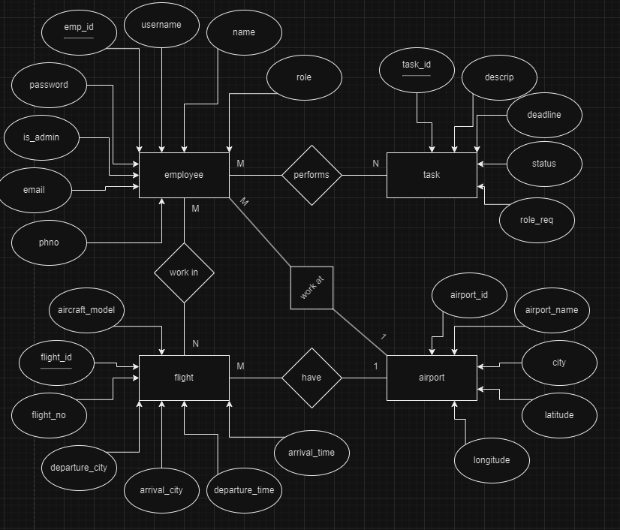

### RELATIONAL SCHEMA:

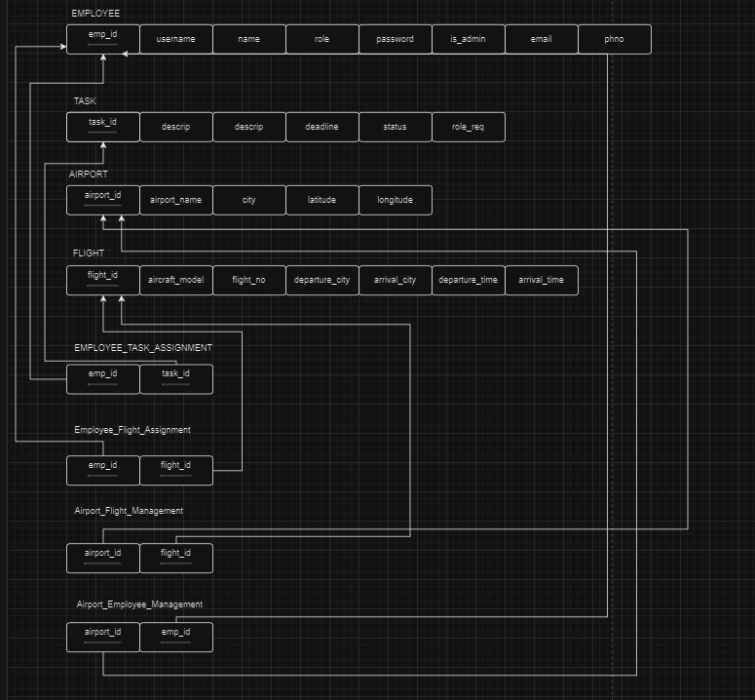

### SQL Database Creation:

mysql> create database airlineDBMS;

Query OK, 1 row affected (0.00 sec)

mysql> use airlinedbms;

Database changed

mysql> CREATE TABLE Employee (

-> emp_id INT PRIMARY KEY AUTO_INCREMENT,

-> username VARCHAR(50) NOT NULL UNIQUE,

-> password VARCHAR(256) NOT NULL,

-> is_admin BOOLEAN NOT NULL,

-> name VARCHAR(100),

-> email VARCHAR(100),

-> phno VARCHAR(20),

-> role VARCHAR(50)

-> );

Query OK, 0 rows affected (0.01 sec)

mysql> CREATE TABLE Task (

-> task_id INT PRIMARY KEY AUTO_INCREMENT,

-> descrip TEXT NOT NULL,

-> deadline DATETIME NOT NULL,

-> status VARCHAR(20) NOT NULL DEFAULT 'Not Started',

-> roles_req VARCHAR(50) NOT NULL

-> );

Query OK, 0 rows affected (0.01 sec)

mysql> CREATE TABLE Flight (

-> flight_id INT PRIMARY KEY AUTO_INCREMENT,

-> flight_no VARCHAR(20) NOT NULL,

-> departure_city VARCHAR(50) NOT NULL,

-> arrival_city VARCHAR(50) NOT NULL,

-> depature_time DATETIME NOT NULL,

-> arrival_time DATETIME NOT NULL,

-> aircraft_model VARCHAR(50) NOT NULL

-> );

Query OK, 0 rows affected (0.01 sec)

mysql> CREATE TABLE Airport (

-> airport_id INT PRIMARY KEY AUTO_INCREMENT,

-> airport_name VARCHAR(100) NOT NULL,

-> city VARCHAR(50) NOT NULL,

-> latitude DECIMAL(10,8),

-> longitude DECIMAL(11,8)

-> );

Query OK, 0 rows affected (0.01 sec)

mysql> CREATE TABLE Employee_Task_Assignment (

-> emp_id INT,

-> task_id INT,

-> PRIMARY KEY (emp_id, task_id),

-> FOREIGN KEY (emp_id) REFERENCES Employee(emp_id),

-> FOREIGN KEY (task_id) REFERENCES Task(task_id)

-> );

Query OK, 0 rows affected (0.02 sec)

mysql> CREATE TABLE Employee_Flight_Assignment (

-> emp_id INT,

-> flight_id INT,

-> PRIMARY KEY (emp_id, flight_id),

-> FOREIGN KEY (emp_id) REFERENCES Employee(emp_id),

-> FOREIGN KEY (flight_id) REFERENCES Flight(flight_id)

-> );

Query OK, 0 rows affected (0.01 sec)

mysql> CREATE TABLE Airport_Flight_Management (

-> airport_id INT,

-> flight_id INT,

-> PRIMARY KEY (airport_id, flight_id),

-> FOREIGN KEY (airport_id) REFERENCES Airport(airport_id),

-> FOREIGN KEY (flight_id) REFERENCES Flight(flight_id)

-> );

Query OK, 0 rows affected (0.02 sec)

mysql> CREATE TABLE Airport_Employee_Management (

-> airport_id INT,

-> emp_id INT,

-> PRIMARY KEY (airport_id, emp_id),

-> FOREIGN KEY (airport_id) REFERENCES Airport(airport_id),

-> FOREIGN KEY (emp_id) REFERENCES Employee(emp_id)

-> );

Query OK, 0 rows affected (0.02 sec)

### Data Entry into Airline Database:

#### For employee table:

mysql> INSERT INTO Employee (username, password, is_admin, name, email, phno, role)

-> VALUES

-> ('admin1', 'password1', TRUE, 'Admin One', 'admin1@example.com', '1234567890', 'admin'),

-> ('admin2', 'password2', TRUE, 'Admin Two', 'admin2@example.com', '1234567891', 'admin'),

-> ('admin3', 'password3', TRUE, 'Admin Three', 'admin3@example.com', '1234567892', 'admin'),

-> ('admin4', 'password4', TRUE, 'Admin Four', 'admin4@example.com', '1234567893', 'admin'),

-> ('admin5', 'password5', TRUE, 'Admin Five', 'admin5@example.com', '1234567894', 'admin');

Query OK, 5 rows affected (0.00 sec)

Records: 5 Duplicates: 0 Warnings: 0

mysql> INSERT INTO Employee (username, password, is_admin, name, email, phno, role)

-> VALUES

-> ('pilot1', 'password6', FALSE, 'Pilot One', 'pilot1@example.com', '1234567895', 'pilot'),

-> ('pilot2', 'password7', FALSE, 'Pilot Two', 'pilot2@example.com', '1234567896', 'pilot'),

-> ('pilot3', 'password8', FALSE, 'Pilot Three', 'pilot3@example.com', '1234567897', 'pilot'),

-> ('pilot4', 'password9', FALSE, 'Pilot Four', 'pilot4@example.com', '1234567898', 'pilot'),

-> ('pilot5', 'password10', FALSE, 'Pilot Five', 'pilot5@example.com', '1234567899', 'pilot');

Query OK, 5 rows affected (0.00 sec)

Records: 5 Duplicates: 0 Warnings: 0

mysql> INSERT INTO Employee (username, password, is_admin, name, email, phno, role)

-> VALUES

-> ('attendant1', 'password11', FALSE, 'Attendant One', 'attendant1@example.com', '1234567800', 'attendant'),

-> ('attendant2', 'password12', FALSE, 'Attendant Two', 'attendant2@example.com', '1234567801', 'attendant'),

-> ('attendant3', 'password13', FALSE, 'Attendant Three', 'attendant3@example.com', '1234567802', 'attendant'),

-> ('attendant4', 'password14', FALSE, 'Attendant Four', 'attendant4@example.com', '1234567803', 'attendant'),

-> ('attendant5', 'password15', FALSE, 'Attendant Five', 'attendant5@example.com', '1234567804', 'attendant');

Query OK, 5 rows affected (0.00 sec)

Records: 5 Duplicates: 0 Warnings: 0

mysql> INSERT INTO Employee (username, password, is_admin, name, email, phno, role)

-> VALUES

-> ('mechanic1', 'password16', FALSE, 'Mechanic One', 'mechanic1@example.com', '1234567805', 'mechanic'),

-> ('mechanic2', 'password17', FALSE, 'Mechanic Two', 'mechanic2@example.com', '1234567806', 'mechanic'),

-> ('mechanic3', 'password18', FALSE, 'Mechanic Three', 'mechanic3@example.com', '1234567807', 'mechanic'),

-> ('mechanic4', 'password19', FALSE, 'Mechanic Four', 'mechanic4@example.com', '1234567808', 'mechanic'),

-> ('mechanic5', 'password20', FALSE, 'Mechanic Five', 'mechanic5@example.com', '1234567809', 'mechanic');

Query OK, 5 rows affected (0.00 sec)

Records: 5 Duplicates: 0 Warnings: 0

mysql> INSERT INTO Employee (username, password, is_admin, name, email, phno, role)

-> VALUES

-> ('ground1', 'password21', FALSE, 'Ground Staff One', 'ground1@example.com', '1234567810', 'ground staff'),

-> ('ground2', 'password22', FALSE, 'Ground Staff Two', 'ground2@example.com', '1234567811', 'ground staff'),

-> ('ground3', 'password23', FALSE, 'Ground Staff Three', 'ground3@example.com', '1234567812', 'ground staff'),

-> ('ground4', 'password24', FALSE, 'Ground Staff Four', 'ground4@example.com', '1234567813', 'ground staff'),

-> ('ground5', 'password25', FALSE, 'Ground Staff Five', 'ground5@example.com', '1234567814', 'ground staff');

Query OK, 5 rows affected (0.00 sec)

Records: 5 Duplicates: 0 Warnings: 0

#### For airport:

mysql> INSERT INTO Airport (airport_name, city, latitude, longitude)

-> VALUES ('Los Angeles International Airport', 'Los Angeles', 33.9425, -118.4081);

Query OK, 1 row affected (0.00 sec)

mysql> INSERT INTO Airport (airport_name, city, latitude, longitude)

-> VALUES ('Heathrow Airport', 'London', 51.4700, -0.4543);

Query OK, 1 row affected (0.00 sec)

mysql> INSERT INTO Airport (airport_name, city, latitude, longitude)

-> VALUES ('Tokyo Haneda Airport', 'Tokyo', 35.5533, 139.7811);

Query OK, 1 row affected (0.00 sec)

mysql> INSERT INTO Airport (airport_name, city, latitude, longitude)

-> VALUES ('Dubai International Airport', 'Dubai', 25.2532, 55.3657);

Query OK, 1 row affected (0.00 sec)

mysql> INSERT INTO Airport (airport_name, city, latitude, longitude)

-> VALUES ('Singapore Changi Airport', 'Singapore', 1.3644, 103.9915);

Query OK, 1 row affected (0.00 sec)

mysql> INSERT INTO Airport (airport_name, city, latitude, longitude)

-> VALUES ('Sydney Kingsford Smith Airport', 'Sydney', -33.9461, 151.1772);

Query OK, 1 row affected (0.00 sec)

mysql> INSERT INTO Airport (airport_name, city, latitude, longitude)

-> VALUES ('Denver International Airport', 'Denver', 39.8561, -104.6737);

Query OK, 1 row affected (0.00 sec)

mysql> INSERT INTO Airport (airport_name, city, latitude, longitude)

-> VALUES ('Hong Kong International Airport', 'Hong Kong', 22.3080, 113.9185);

Query OK, 1 row affected (0.00 sec)

mysql> INSERT INTO Airport (airport_name, city, latitude, longitude)

-> VALUES ('Frankfurt Airport', 'Frankfurt', 50.0336, 8.5706);

Query OK, 1 row affected (0.00 sec)

mysql> INSERT INTO Airport (airport_name, city, latitude, longitude)

-> VALUES ('Incheon International Airport', 'Incheon', 37.4692, 126.4505);

Query OK, 1 row affected (0.00 sec)

#### For flight:

mysql> INSERT INTO Flight (flight_no, departure_city, arrival_city, depature_time, arrival_time, aircraft_model)

-> VALUES ('FL001', 'Los Angeles', 'Heathrow', '2023-11-15 08:00:00', '2023-11-15 16:00:00', 'Boeing 777');

Query OK, 1 row affected (0.00 sec)

mysql> INSERT INTO Flight (flight_no, departure_city, arrival_city, depature_time, arrival_time, aircraft_model)

-> VALUES ('FL002', 'Tokyo', 'Dubai', '2023-11-16 12:00:00', '2023-11-16 18:00:00', 'Airbus A380');

Query OK, 1 row affected (0.00 sec)

mysql> INSERT INTO Flight (flight_no, departure_city, arrival_city, depature_time, arrival_time, aircraft_model)

-> VALUES ('FL003', 'Singapore', 'Sydney', '2023-11-17 10:00:00', '2023-11-17 18:30:00', 'Boeing 747');

Query OK, 1 row affected (0.00 sec)

mysql> INSERT INTO Flight (flight_no, departure_city, arrival_city, depature_time, arrival_time, aircraft_model)

-> VALUES ('FL004', 'Denver', 'Hong Kong', '2023-11-18 09:30:00', '2023-11-18 20:00:00', 'Airbus A330');

Query OK, 1 row affected (0.00 sec)

mysql> INSERT INTO Flight (flight_no, departure_city, arrival_city, depature_time, arrival_time, aircraft_model)

-> VALUES ('FL005', 'Frankfurt', 'Incheon', '2023-11-19 11:30:00', '2023-11-19 18:30:00', 'Boeing 787');

Query OK, 1 row affected (0.00 sec)

#### For task:

Insert tasks for employees

Employees 3 and 4 (Pilots) have 2 tasks each

Employees 5 and 6 (Attendants) have 2 tasks each

Employees 7 and 8 (Mechanics) have 2 tasks each

Employees 9 and 10 (Ground Staff) have 2 tasks each

mysql> INSERT INTO Task (descrip, deadline, status, roles_req)

-> VALUES ('Flight Planning', '2023-11-15 10:00:00', 'Not Started', 'pilot');

Query OK, 1 row affected (0.00 sec)

mysql> INSERT INTO Task (descrip, deadline, status, roles_req)

-> VALUES ('Pre-flight Checks', '2023-11-16 14:00:00', 'Not Started', 'pilot');

Query OK, 1 row affected (0.00 sec)

mysql> INSERT INTO Task (descrip, deadline, status, roles_req)

-> VALUES ('In-flight Navigation', '2023-11-17 12:00:00', 'Not Started', 'pilot');

Query OK, 1 row affected (0.00 sec)

mysql> INSERT INTO Task (descrip, deadline, status, roles_req)

-> VALUES ('Post-flight Checks', '2023-11-18 16:00:00', 'Not Started', 'pilot');

Query OK, 1 row affected (0.00 sec)

mysql> INSERT INTO Task (descrip, deadline, status, roles_req)

-> VALUES ('Cabin Preparation', '2023-11-15 09:30:00', 'Not Started', 'attendant');

Query OK, 1 row affected (0.00 sec)

mysql> INSERT INTO Task (descrip, deadline, status, roles_req)

-> VALUES ('Passenger Assistance', '2023-11-16 15:30:00', 'Not Started', 'attendant');

Query OK, 1 row affected (0.00 sec)

mysql> INSERT INTO Task (descrip, deadline, status, roles_req)

-> VALUES ('Emergency Response Training', '2023-11-17 11:00:00', 'Not Started', 'attendant');

Query OK, 1 row affected (0.00 sec)

mysql> INSERT INTO Task (descrip, deadline, status, roles_req)

-> VALUES ('In-flight Service', '2023-11-18 17:30:00', 'Not Started', 'attendant');

Query OK, 1 row affected (0.00 sec)

mysql> INSERT INTO Task (descrip, deadline, status, roles_req)

-> VALUES ('Aircraft Inspection', '2023-11-15 10:30:00', 'Not Started', 'mechanic');

Query OK, 1 row affected (0.00 sec)

mysql> INSERT INTO Task (descrip, deadline, status, roles_req)

-> VALUES ('Engine Maintenance', '2023-11-16 14:30:00', 'Not Started', 'mechanic');

Query OK, 1 row affected (0.00 sec)

mysql> INSERT INTO Task (descrip, deadline, status, roles_req)

-> VALUES ('Avionics Check', '2023-11-17 12:30:00', 'Not Started', 'mechanic');

Query OK, 1 row affected (0.00 sec)

mysql> INSERT INTO Task (descrip, deadline, status, roles_req)

-> VALUES ('Landing Gear Inspection', '2023-11-18 16:30:00', 'Not Started', 'mechanic');

Query OK, 1 row affected (0.00 sec)

mysql> INSERT INTO Task (descrip, deadline, status, roles_req)

-> VALUES ('Baggage Handling', '2023-11-15 09:00:00', 'Not Started', 'ground staff');

Query OK, 1 row affected (0.00 sec)

mysql> INSERT INTO Task (descrip, deadline, status, roles_req)

-> VALUES ('Check-in Assistance', '2023-11-16 15:00:00', 'Not Started', 'ground staff');

Query OK, 1 row affected (0.00 sec)

mysql> INSERT INTO Task (descrip, deadline, status, roles_req)

-> VALUES ('Security Check', '2023-11-17 11:30:00', 'Not Started', 'ground staff');

Query OK, 1 row affected (0.00 sec)

mysql> INSERT INTO Task (descrip, deadline, status, roles_req)

-> VALUES ('Gate Operations', '2023-11-18 17:00:00', 'Not Started', 'ground staff');

Query OK, 1 row affected (0.00 sec)

#### Assigning values to relational tables:

mysql> INSERT INTO Airport_Employee_Management (airport_id, emp_id)

-> VALUES (1, 1), (1, 2), (2, 3), (2, 4), (3, 5), (3, 6), (4, 7), (4, 8), (5, 9), (5, 10);

Query OK, 10 rows affected (0.00 sec)

Records: 10 Duplicates: 0 Warnings: 0

mysql> INSERT INTO Airport_Flight_Management (airport_id, flight_id)

-> VALUES (1, 1), (2, 2), (3, 3), (4, 4), (5, 5);

Query OK, 5 rows affected (0.00 sec)

Records: 5 Duplicates: 0 Warnings: 0

mysql> INSERT INTO Employee_Flight_Assignment (emp_id, flight_id)

-> VALUES (5, 1), (6, 1), (7, 2), (8, 2), (9, 3), (10, 3), (1, 4), (2, 4), (3, 5), (4, 5);

Query OK, 10 rows affected (0.00 sec)

Records: 10 Duplicates: 0 Warnings: 0

mysql> INSERT INTO Employee_Task_Assignment (emp_id, task_id)

-> VALUES (1, 1), (2, 1), (3, 2), (4, 2), (5, 3), (6, 3), (7, 4), (8, 4), (9, 5), (10, 5);

Query OK, 10 rows affected (0.00 sec)

Records: 10 Duplicates: 0 Warnings: 0

#### CRUD operations Screen-Shot:

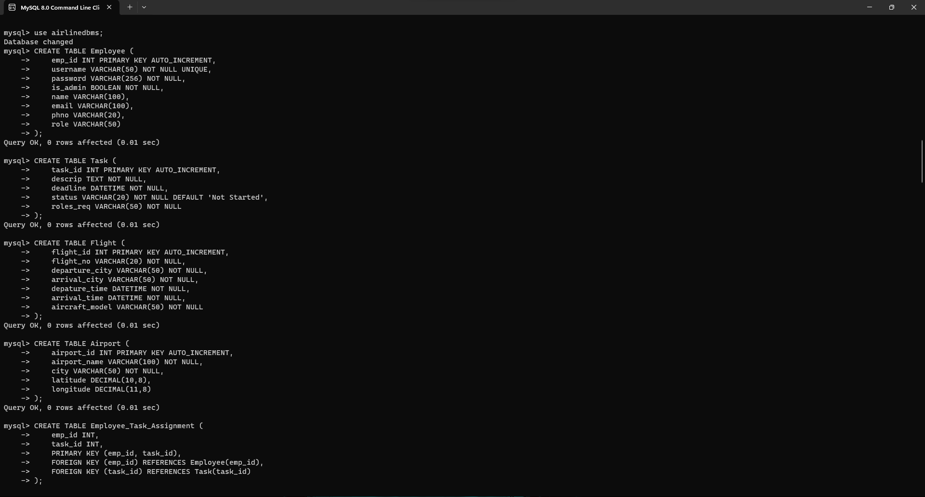

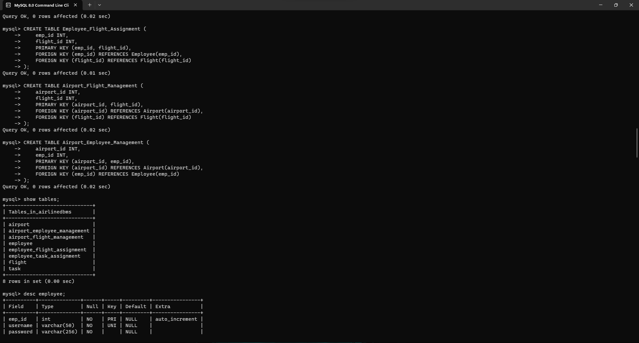

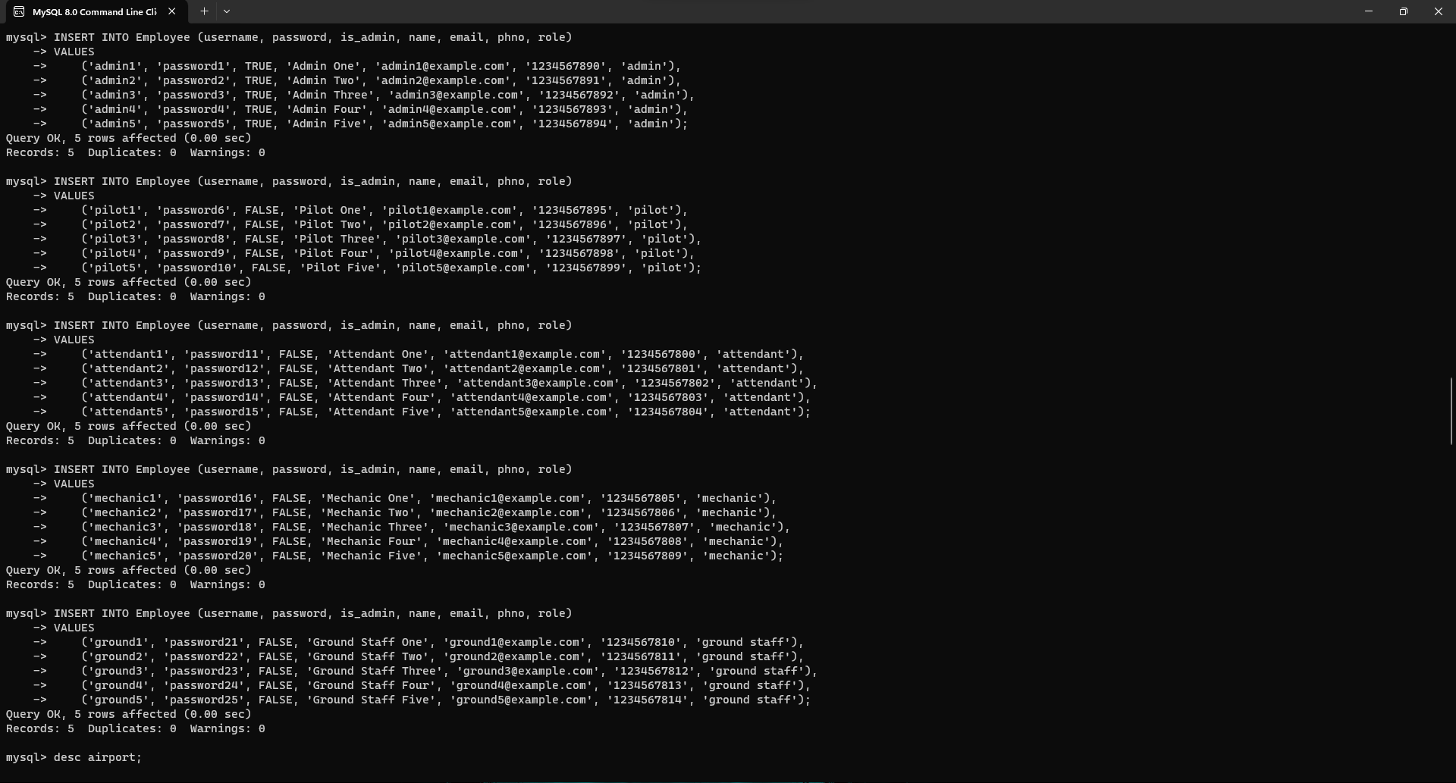

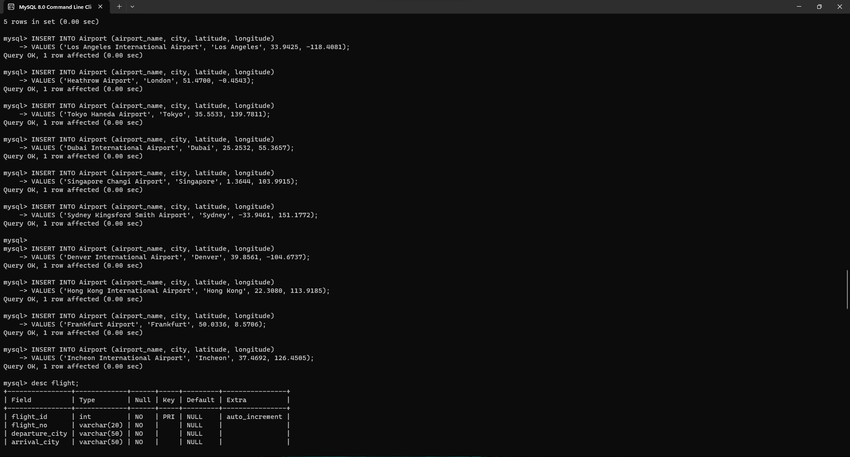

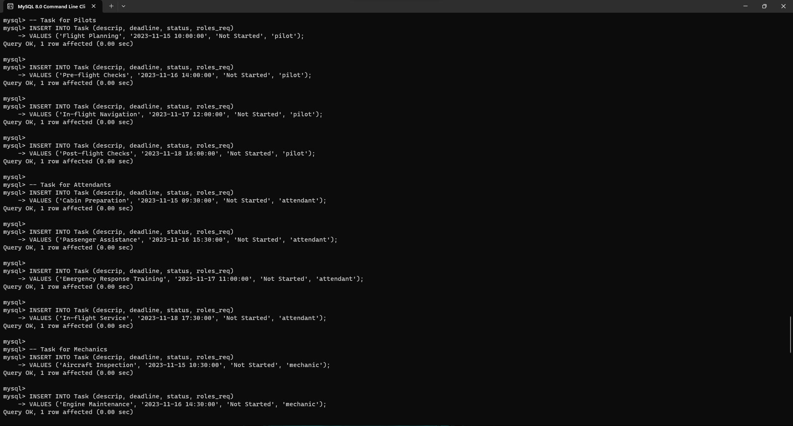

### SQL Procedure Creation:

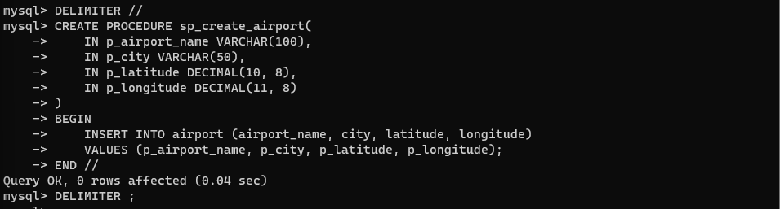

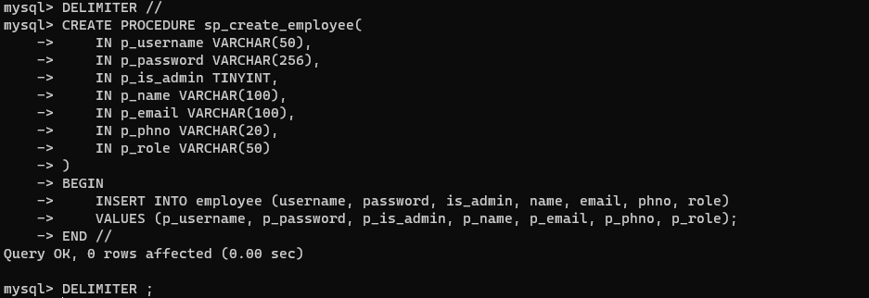

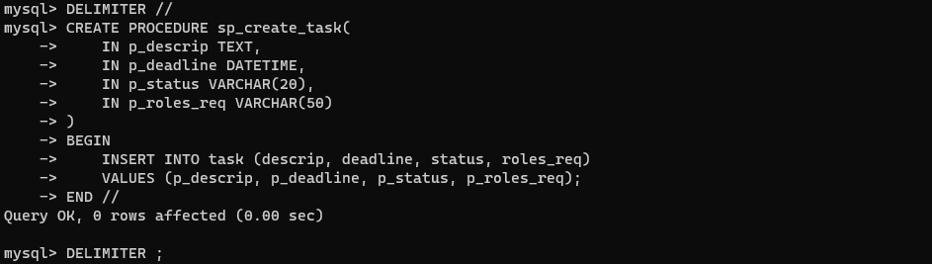

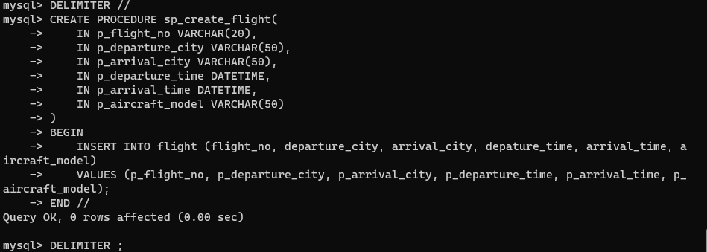

### SQL Trigger Creation:

1)Trigger for updating the employee table:

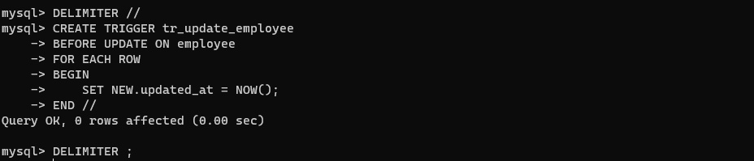

2)Trigger for deleting a row from the task table:

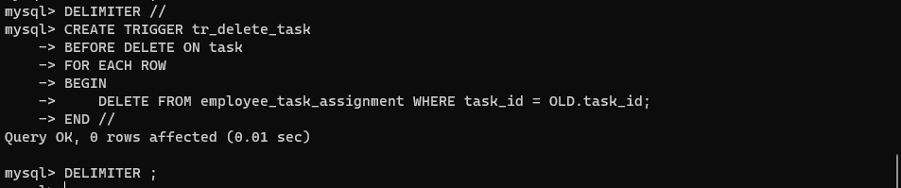

3)Trigger for ensuring unique usernames in the employee table:

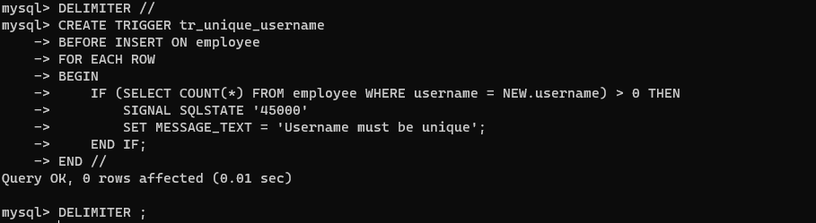

### SQL FUNCTION CREATION:

Count of #assignments assigned to an employee

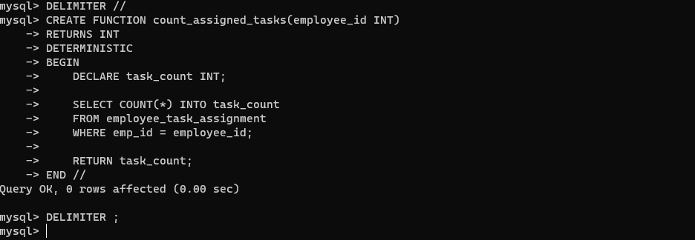

### SQL ADDING USER:

### STREAMLIT FRONTEND SCREENSHOT:

main.py

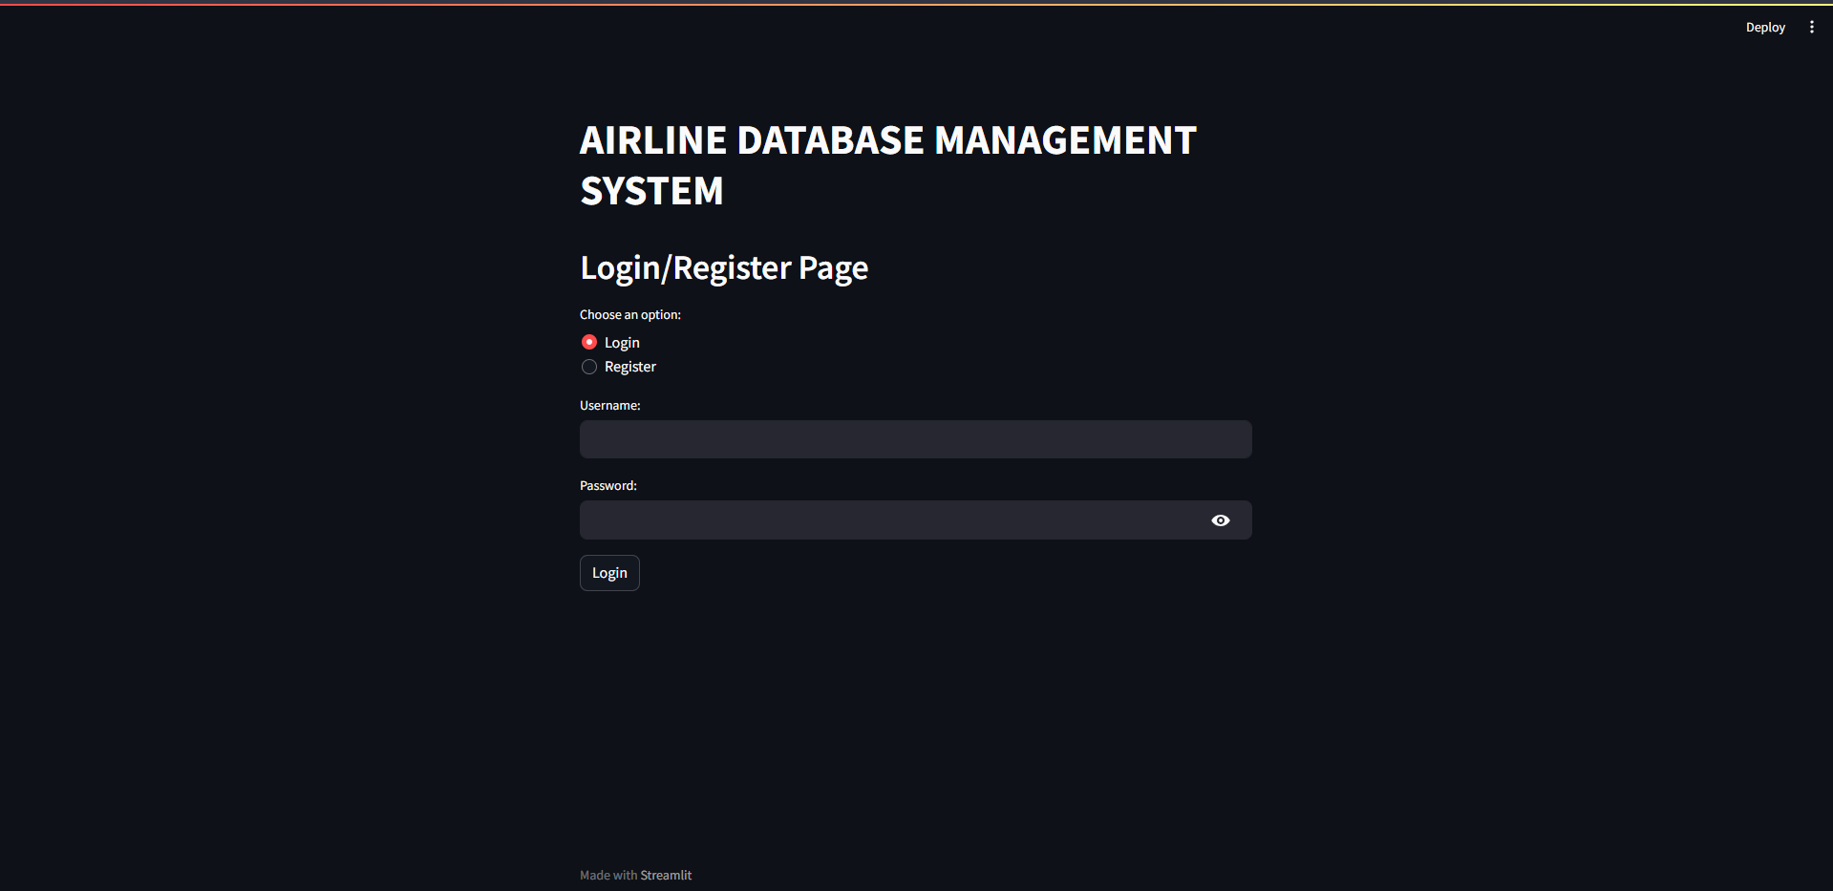

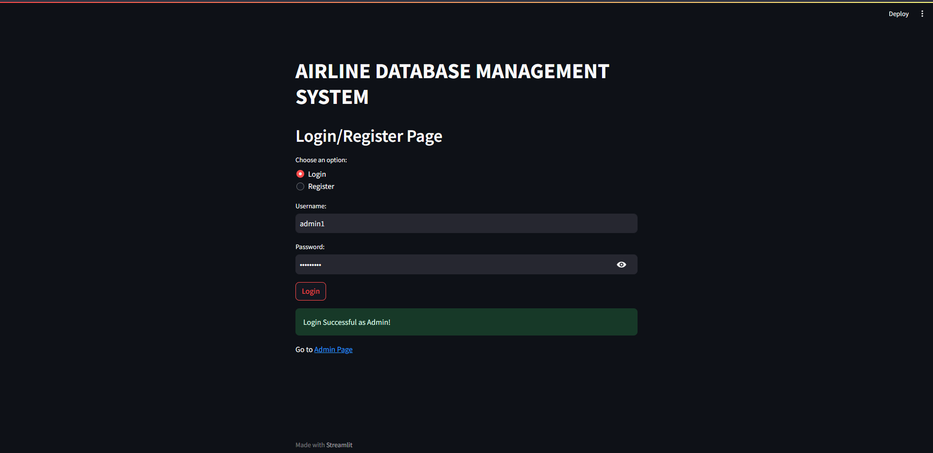

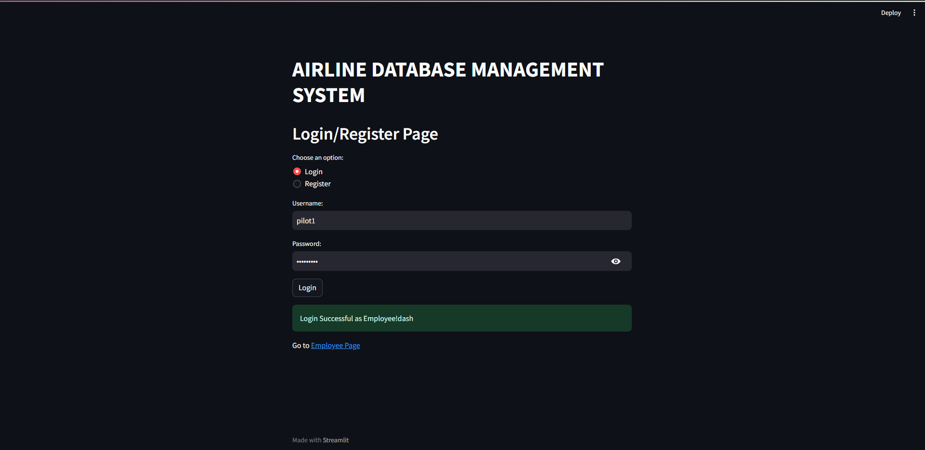

emp.py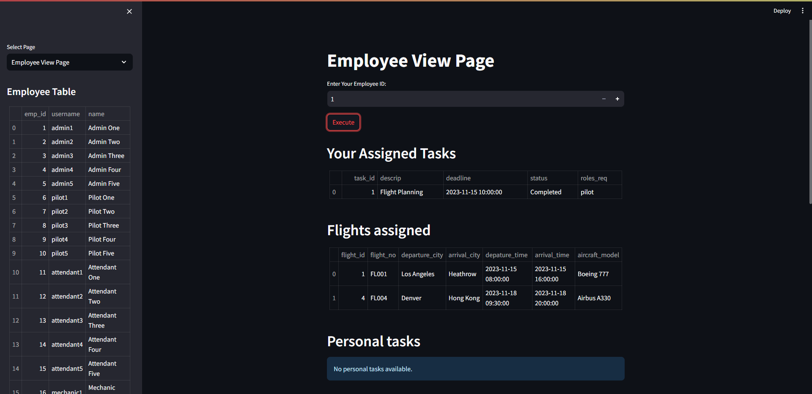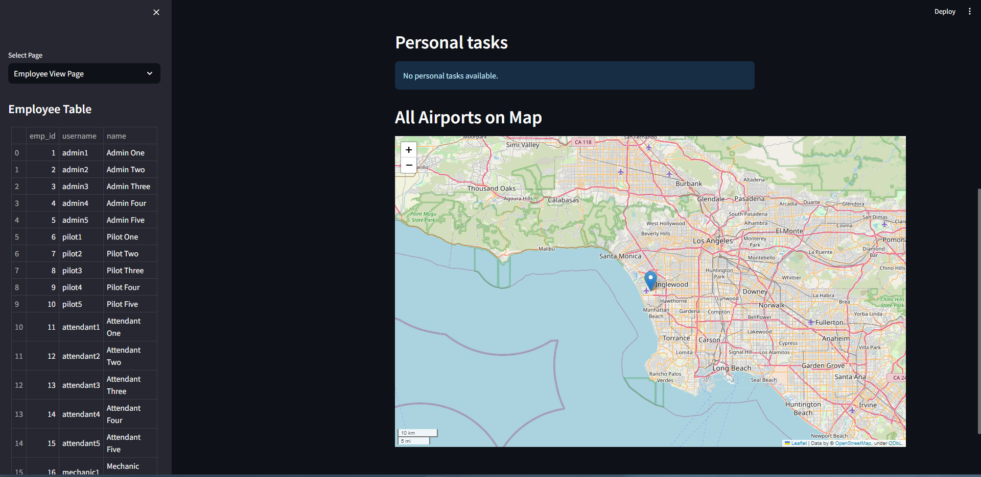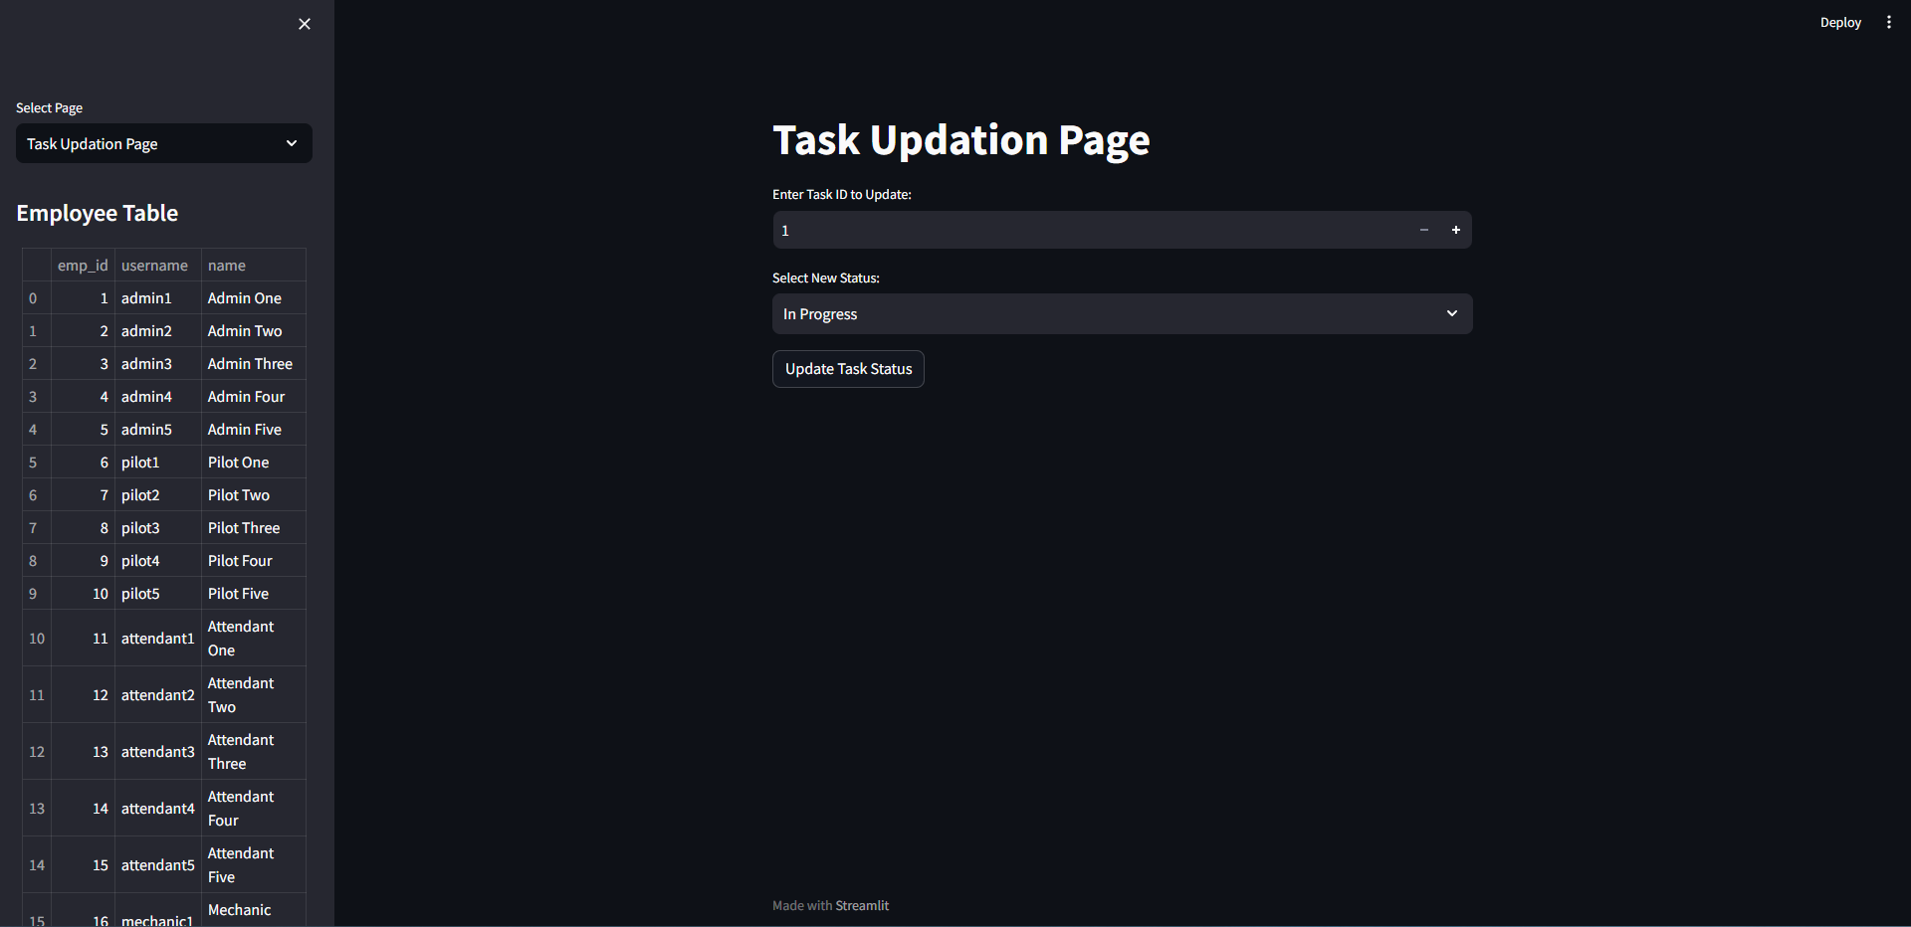

admin.py

